3GPP TSG RAN WG1 #125 R1-2603538
Dalian, China, May 18th – 22nd, 2026
Agenda item: 10.8.3
Source: Nokia
Title: Waveform and frame structure for 6GR Sensing
Document for: Discussion and Decision

Introduction
The 3GPP RAN plenary RAN#110 has approved a new SID, “Study on 6G Radio” [1]. Sensing was included as one of the focus areas. The detailed focus of the study is as follows:
- Sensing – Studies to be based on use cases and associated requirements, as defined in [TR38.914]
- PHY functions and procedures for sensing technology (e.g., waveform. reference signals, measurement feedback, etc…) [RAN1, RAN4]
- Evaluate sensing performance and if necessary, extend channel modelling, for the selected use cases [RAN1]
- Aspects of integration with communication services [RAN1]
- higher layer procedures and protocol aspects [RAN2]
- RAN4 aspects of sensing including RF, coexistence, and testability in coordination with other WGs [RAN4]
Note: RAN1 identify detailed requirements, if triggered by TSG RAN

RAN1 has studied integrated sensing and communications (ISAC) in Rel 19 and Rel 20. under the 5G NR framework. In Rel 19 channel modeling for Integrated Sensing and Communications (ISAC) [2-3], five sensing scenarios, including the UAV, Human sensing (indoor and outdoor), Automotive (urban grid and highway), AGV (indoor and outdoor) and Hazard scenarios, and six sensing modes including, TRP monostatic, TRP-TRP bistatic, UE monostatic, UE-UE bistatic, UE- TRP bistatic, and TRP-UE bistatic modes were considered. Using the TR 38.901 channel models as baseline, the target channel and background channel models for system level evaluations were developed. The RCS models for several sensing scenarios and modes were also developed.
In the Rel 20 study item, the feasibility of the integrated sensing and communications (ISAC) in the 5G NR system for the UAV scenario in a gNB monostatic mode was investigated by taking the Rel 19 study as the starting point. The 5G NR system (including waveforms, reference signals, resource allocation granularities, etc.) served as the baseline, and the sensing functionality for the UAV scenario in a gNB monostatic mode was developed. Six performance objective values were agreed upon. Four levels of sensing data formats were agreed with several options in each level. For the simulation campaign, two sets of baseline configurations were considered and simulations results were included in the TR 38.901.
Looking beyond 5G NR, sensing is expected to become a native capability of 6GR systems rather than a reuse of features developed for communications to ISAC in 5G [1]. The 6G sensing aims to support high‑resolution, multi‑modal, and multi‑target sensing across diverse environments by leveraging wider bandwidths, large‑scale antenna arrays, and tighter integration between sensing, communication, and computing. Compared to 5G NR ISAC, 6G sensing is envisioned to enable a few important use cases, with performance objectives aligned with ITU requirements.

The waveforms, reference signals, frame structure, and measurement procedures are the basic aspects of the 6G sensing study [1]. The RAN1 6GR study has made initial guidelines for the waveforms for communications. In this contribution, we discuss the following in detail
- DFT-s-OFDM as UE side sensing TX waveform
- Enhancements for Sensing waveforms
  - CP-OFDM
  - DFT-S-OFDM
  - Pulse type waveforms
- Frame structure for 6GR sensing
- Evaluations of waveforms
  - LLS versus simplified SLS
  - Evaluation assumptions
  - Performance metric for comparison
    - Performance metrics aligned with Rel 20 5G NR/ITU-R performance metrics
    - Waveform Characteristics -PAPR, Ambiguity function, PSLR, ACLR,OBO, OOBE
  - Initial waveform comparison results

Discussion

Baseline 6GR communication Waveforms
In RAN1-#122 and RAN1-#124, the following agreements and conclusions were reached on the waveforms for 6GR in the uplink and downlink.
Agreement(RAN1-#122)
CP-OFDM and DFT-s-OFDM waveforms as defined in 5G NR are supported as the basis for 6GR for uplink
- Enhancements/modifications on CP-OFDM/DFT-s-OFDM will be studied as potential additions
- Other OFDM based waveforms are not precluded.

Conclusion:(RAN1-#124)
DFT-s-OFDM waveform including related enhancements for 6GR Downlink will be no further discussed as part of AI 10.2.1.
- Note: for DL signal (e.g., SS, WUS, sensing), it may or may not be separately discussed in corresponding AI.

In addition, in RAN1-#124bis, the following agreement was made in the 6G sensing study
Agreement::(RAN1-#124bis)
CP-OFDM waveform as defined for 6GR is the starting point for 6G ISAC waveform study.
Study on enhancements on CP-OFDM or other waveforms is not precluded.

These agreements provide important guidelines for the. 6G waveforms study. In our view, communications and sensing should use the same waveforms as much as possible unless substantial benefits and performance discrepancies are evident. The same waveform for different verticals helps with the development, testing, and economies of scale. As the CP-OFDM and DFT-s-OFDM are the basis of the uplink communications, and CP-OFDM is the basis of the DL communications, and CP-OFDM is the starting point for the 6G ISAC waveform study, we should agree DFT-s-OFDM as one of the UE side sensing TX waveforms in the 6G ISAC study
Proposal 1: DFT-S-OFDM is studied as one of the UE-side sensing TX waveforms for 6GR sensing.
DFT-s-OFDM is generally avoided for 6G downlink sensing because it offers significantly lower sensing accuracy and resolution compared to CP-OFDM. While its low power consumption is a major benefit for mobile devices in the uplink, this advantage is less critical for base stations in the downlink. Instead, the waveform’s single-carrier nature creates a non-flat spectrum and a higher noise floor, which degrades range and velocity estimation. Furthermore, DFT-s-OFDM lacks the flexibility required for multi-user MIMO or beamforming or high-rank spatial multiplexing, making it less efficient for the high-capacity, multi-target sensing environments for 6G. Moreover, aligning with the conclusion in RAN1-#124bis on 6GR DL communications waveform, DFT-S-OFDM should be excluded for the aNB-side sensing TX waveform for 6G sensing.
Proposal 2. DFT-S-OFDM is not considered as one of the aNB-side sensing TX waveforms for 6GR sensing.

Enhancements to Sensing waveforms
2.2.1. CP-OFDM as an NB and UE TX waveform

CP-OFDM has a huge, proven 3GPP LTE and 5G NR installed base around the world and has a mature ecosystem (silicon blocks, channel estimation/equalization, test equipment, conformance), so keeping it lowers cost, power, validation effort, and time-to-market. Technically, the cyclic prefix enables simple per‑subcarrier (one‑tap) equalization in frequency‑selective channels and fits naturally with massive‑MIMO/beamforming and flexible numerologies/BWPs. The out‑of‑band emissions and PAPR might be a concern, but they are manageable using established mitigation techniques (windowing/filtering, frequency domain shaping, guard bands, scheduling constraints, and mature PA/DPD at the base station).
CP‑OFDM is also attractive for 6G sensing or integrated sensing and communications (ISAC) because we may reuse or slightly update the mature 4G/5G NR downlink waveform, reference signals, and FFT‑based receiver chain for sensing, keeping complexity, cost, standardization, and implementation risk low. Its multicarrier structure makes sensing parameter extraction natural: propagation delay appears as a phase slope across subcarriers (enabling range estimation with wide bandwidth), Doppler appears as phase evolution across OFDM symbols (enabling velocity estimation over coherent bursts), and multi‑antenna CP‑OFDM integrates cleanly with massive‑MIMO beams for angle/spatial sensing. The cyclic prefix improves robustness in multipath and supports efficient frequency‑domain processing, while flexible numerology, bandwidth parts, and pilot patterns allow tuning the sensing/communications trade‑off (resolution, unambiguous range/velocity, and overhead) without introducing a separate new waveform.
Based on the RAN1 agreement captured in Section 2.1, CP-OFDM should be considered the preferred downlink (DL) waveform for 6GR sensing/ISAC. CP-OFDM is already supported as the basis DL waveform for 6GR, and it offers the best overall balance of ecosystem maturity, implementation risk, and seamless multiplexing/integration with the communications framework. Any DL waveform enhancements for sensing should therefore be studied as evolutionary additions on top of CP-OFDM, while retaining compatibility with the baseline CP-OFDM characteristics.
In the downlink, pulse signal can be framed as a CP-OFDM based solution by treating pulse/chirps as dedicated sensing bursts/signals carried within the CP OFDM frame structure (i.e., scheduled sensing occasions), while keeping CP OFDM as the baseline waveform for data and control. This preserves 6GR DL compatibility, multiplexing, and multiuser/MIMO operation, yet allows radar native processing when higher ranging sensitivity/resolution is required. Such a framework also enables a configurable sensing/communications trade off via resource allocation, without introducing a new “always on” DL waveform.
Proposal 3. Possible enhancements to CP-OFDM will be studied in RAN1 for 6GR sensing for aNB and UE transmitting waveforms, including pulse-type signals. They are
  - PAPR reduction
  - Reduction of PSLR and ISLR
  - Ambiguity function reduction

2.2.2 DFT-s-OFDM as UE transmission waveform
DFT-s-OFDM can be attractive for downlink when transmit power efficiency, and coverage are critical because its single-carrier–like structure yields lower PAPR than CP-OFDM, letting the base-station power amplifier operate with less back-off (higher efficiency) or, for the same PA, deliver more cell-edge EIRP. It can also reduce sensitivity to nonlinear distortion and spectral regrowth, potentially easing emission constraints and improving robustness for wideband transmissions, especially in high-frequency bands where linearity is costly. Because it still uses CP and FFT-based processing, it retains much of OFDM’s frequency-domain equalization simplicity and can fit into similar scheduling/resource-grid frameworks, making it a relatively evolutionary option where DL energy efficiency and coverage are prioritized.
DFT-s-OFDM can be attractive for 6G sensing/ISAC mainly because its lower PAPR enables more power-efficient transmission (less PA back-off) and cleaner spectra (less nonlinear distortion and spectral regrowth), which translates into higher usable average radiated power and a “cleaner” sensing illumination—improving detection range/SNR and reducing spurious peaks that can mask weak targets, especially at high bands where PA linearity is expensive. Because it still uses a cyclic prefix and FFT-based processing, many OFDM sensing ideas carry over (using known pilots/data for matched filtering, estimating delay/Doppler from coherent processing across time/frequency), while the DFT-spread structure can yield more stable time-domain envelopes that help dynamic-range–limited ISAC setups (e.g., co-located TX/RX with self-interference cancellation) and support flexible resource allocation for sensing bursts without abandoning the existing cellular frame structure.
For the UE transmission, both CP-OFDM and DFT-S-OFDM are well-suited waveforms candidates for sensing/ISAC, in line with the baseline 6GR waveform agreement in Section 2.1 and the general rationale to reuse OFDM family waveforms where possible. CP-OFDM enables straightforward FFT-based delay/Doppler processing and clean integration with existing UL reference signals and multiantenna reception. DFT-S-OFDM complements this by offering lower PAPR and improved UE power amplifier efficiency, which can translate into higher average radiated power (or longer battery life) and more stable sensing illumination, while still retaining CP/FFT-based receiver processing and resource grid compatibility. Therefore, UL sensing enhancements should primarily be studied as evolutionary extensions on top of CP-OFDM and DFT-S-OFDM, preserving their baseline characteristics.
In the 6GR communications for the UL transmission enhancements to DFT-S-OFDM waveform have been studied. To keep the additional implementation complexity to a minimum, we recommend studying those enhancements first for 6G sensing. If they are inadequate, we may look at additional enhancements for 6G sensing.
Proposal 4: The enhancements to DFT-S-OFDM in the 6G UL communication are the starting point of the enhancements to DFT-S-OFDM for 6G sensing.
Proposal 5. Additional enhancements to DFT-S-OFDM may be studied in RAN1 for 6GR sensing for UE transmitting waveform, including pulse-type signals They are
  - PAPR reduction
  - Reduction of PSLR and ISLR
  - Ambiguity function reduction
  - FDSS

2.2.3 Pulse waveform for aNB and UE transmission
Using OFDM for a communications framework and inserting LFM chirp/ pulses/bursts for sensing is also a possibility. Keeping the cellular air interface largely intact, while leveraging a radar-native waveform when we want high-quality ranging. Pairing OFDM for communications with occasional chirp/bursts of pulses for sensing lets each waveform do what it’s best at: OFDM keeps the cellular link efficient and flexible for high data rates, multiuser scheduling, and MU‑MIMO/beamforming, while pulse signal delivers strong ranging performance (high range resolution and good sensitivity) with relatively simple radar processing. Because the sensing can be inserted as dedicated bursts within an otherwise standard OFDM frame, it also supports more incremental deployment and gives the network an adjustable trade‑off—allocate more chirps when sensing accuracy matters, and more OFDM resources when traffic demand is higher.
The LFM pulse waveform is a good candidate for 6G sensing because it offers an exceptional balance between high-resolution performance and hardware efficiency. Its primary benefit lies in Pulse Compression, which allows the system to transmit long, energy-rich pulses for long-range detection while achieving the fine range resolution typically associated with much shorter pulses. Furthermore, LFM is characterized by a low and constant Peak-to-Average Power Ratio (PAPR), enabling power amplifiers to operate at maximum efficiency near saturation with minimal Output Backoff (OBO). This hardware-friendly nature is crucial for 6G's goal of integrating sensing into mobile devices without draining battery life or requiring expensive, ultra-linear components. Additionally, its well-defined Ambiguity Function provides predictable performance in measuring both distance and velocity, making it a reliable candidate for 6G Integrated Sensing and Communication (ISAC) waveforms.
Proposal 6. Study the LFM pulse -type signal in the CP-OFDM and DFT-S-OFDM framework for 6G Sensing

Frame structure for 6GR sensing
In RAN1#124bis, the following agreement was made on 6G ISAC frame structure.
Agreement RAN1#124bis:
6GR communication frame structure is the starting point for 6G ISAC frame structure study, in at least the following aspects.
  - Frame/sub-frame/slot/symbol structure
  - CP length
  - SCS
Enhancements on frame structure/above aspects are not precluded.

The open question is how sensing occasions are configured on top of this 6GR communications frame structure. From our perspective, two options can be considered for study:
- Option 1 (Lookup-table-based configuration): A predefined table is specified, where each entry (e.g., a sensing configuration index (SCI)) points to a sensing time pattern.
- Option 2 (Parametrized configuration): Sensing occasions are described by a set of configuration parameters (e.g., periodicity, offset, starting symbol, duration), without relying on a predefined table.

Furthermore, two aspects deserve some discussion:
- Which 6GR symbol types can be used for sensing: DL, UL, flexible (FL), guard period, SBFD, new sensing symbols or a mix of them.
- Whether the configuration of sensing occasions in time and in frequency uses a common set of parameters or separate sets.

Proposal 7: Study the following options for the configuration of sensing occasions on top of the 6GR communication frame structure:
- Option 1: Lookup-table-based configuration.
- Option 2: Parametrized configuration.

Proposal 8: Study which 6GR symbol types (DL, UL, flexible, guard period, SBFD, sensing symbols or a mix) can be used for sensing.
Proposal 9: Study whether time-domain and frequency-domain configuration of sensing occasions are configured by separate parameters.

Evaluations of Waveforms for 6G Sensing
2.4.1 LLS versus Simplified SLS channel model
Performing a performance comparison of candidate waveforms for 6G sensing is essential for understanding the trade‑offs among sensing accuracy, communication efficiency, and implementation complexity. Such comparisons help identify which waveforms are better suited for specific sensing KPIs, such as miss detection, false alarm, range/Doppler resolution, robustness to interference, latency, etc. Evaluations based on common, agreed-upon evaluation assumptions are also important for achieving consensus and agreeing on a waveform for 6G sensing. This enables fair, evidence‑based technology selection, avoids over‑optimistic claims tied to specific waveform designs, and supports informed standardization decisions for flexible sensing operation in diverse deployment scenarios.
For 6G Integrated Sensing and Communication (ISAC), choosing the right simulation level is a trade-off between detail and scale. While System-Level Simulations (SLSs) are necessary for network planning and multi-cell interference analysis, Link-Level Simulations (LLSs) are better suited for transmit waveform comparison because they focus on the Physical Layer (PHY) and provide high-fidelity modeling. In the SLS, system-level artifacts (random target locations/speeds, random UE locations/speeds, random virtual reference point locations) may affect performance and hinder waveform comparison.
The link-level channel model for 5G NR ISAC was discussed in Rel 19, but no agreements were reached.
In TR 38.901, the CDL channel model for link-level simulations under NLOS conditions can be selected, and one or more clusters, depending on the number of scattering points, are updated or newly introduced to match the target channel. The clusters updated or included for the target channel encompass the concatenated channels (STX-Target, Target-SRX) and RCS effect as in sections 7.7.1 and 7.9.4.1 of TR 38.901.
Proposal 10: Link-level channel modeling is necessary for waveform and sensing reference signal comparisons
Proposal 11: The CDL model is used as the 6G ISAC link-level channel model with one or more clusters for target channel clusters.
Option1: One or more clusters in the CDL channel model are updated
Option2: One or more clusters are added to the CDL channel model
The channel generation steps and parameter values of the target cluster(s) are FFS.

2.4.2 Waveform characteristics for Performance comparison
Waveform characteristics are essential for evaluating Integrated Sensing and Communication (ISAC) in the 6G sensing study. They provide a standardized way to compare how different waveforms meet the requirements of high-speed data transmission, high-precision environmental mapping (sensing), and the coexistence or integration of sensing and communication. The waveform characteristics include the PAPR, AF (Ambiguity function), PSLR, ISLR, Output backoff (OBO), ACLR, OOBE, etc. The definitions of PAPR, ACLR, OBO, OOBE, etc. were used in the RAN1 and RAN4 evaluations (TS 38.101) and they are used here as well.
Ambiguity Function (AF): Shows how well a waveform can distinguish between multiple targets in terms of distance (delay) and speed (Doppler). A narrow central peak indicates high resolution, while "side lobes" represent potential false detections. It is defined as
$AF\left(τ,v\right)=\int_{Φ}{s\left(t\right)s^{}\left(t-τ\right)e^{i2πvt}}dt$,
$Φ$ = the region of interest of the ambiguity function
$τ$ = delay
$v$ = Doppler with continuous value

Peak-to-Sidelobe Ratio (PSLR): Measures the strength of the main target signal relative to the largest false peak. High PSLR is critical for detecting small objects (like a drone) near larger ones (like a building)
$PSLR=20log⁡\left(\frac{P_{1}}{P_{0}}\right)$,
$P_{0}$= the largest value of the main lobe power of ambiguity function
$P_{1}$ = the largest value of the side-lobe power of ambiguity function

Integrated Sidelobe Ratio (ISLR): Compares the total energy in all sidelobes to the main peak. Lower ISLR improves the system's ability to "see" clearly in cluttered environments
$ISLR=10log⁡\left(\frac{I_{side-lobe}}{I_{main-lobe}}\right)$,
$I_{main-lobe}$ = the power of the main-lobe
$I_{side-lobe}$ = the total power of side-lobe
Output Backoff (OBO): While communication systems primarily concern themselves with data errors, sensing waveforms are extremely sensitive to the signal's shape. OBO evaluations help to understand the cost of keeping that signal shape intact. OBO evaluations tell exactly how much power must be "given up" to keep these sidelobes low enough to detect small objects
Proposal 12: The following waveform characteristics will be evaluated for waveform comparison in the 6G ISAC.
- PAPR
- Ambiguity Function (AF)
- PSLR
- ISLR
- OBO
- ACLR, OOBE

2.4.3 Evaluation assumptions

Table 2. Evaluation assumptions for 6G sensing waveform comparison
Parameters | Values
Channel model | UMa Outdoor TR 38.901
Carrier frequency, Bandwidth and SCS | 6GHz, 20 MHz, 30 kHz (60, 120 kHz)
Target | Single target, at 180m and 30m/s
RCS | 20 dBsm
CPI | 10ms
Background channel | Yes, 3 virtual reference point-based model TR 38.901
Antenna config | SISO (1Tx1Rx)
Interference modelling | No inter-cell or inter-site interference modelled
Sensing mode | aNB Monostatic
SNR | Ratio of received sensing signal power to background channel power + AWGN power
TX power | SNR-based sweep (direct SNR parameter; TX power and noise figure not separately modelled)  −40 dB to −10 dB, step 2 dB
Self-interference | Not modelled
Waveforms | CP-OFDM, DFT-s-OFDM (transform precoded), OTFS (ISFFT precoded, NR-OFDM modulated)
P_FA (fixed) | 5% (0.05) — Neyman-Pearson criterion; DC Doppler guard ±2 bins applied

2.4.4 Performance metrics for waveforms comparison
For 6G waveform comparisons targeting sensing, the key KPIs focus on how accurately and reliably the waveform enables sensing functions under practical constraints. Core KPIs include range and Doppler resolution, estimation accuracy (e.g., RMSE), maximum unambiguous range and velocity, and target detection performance (probability of miss detection and false alarm). In addition, robustness to interference, mobility, and hardware impairments, along with time–frequency localization and sidelobe leakage, is critical for multi‑target and multi‑TRP sensing. PAPR is also an important KPI, as it directly impacts power amplifier efficiency, sensing SNR, and feasible transmit power, thereby influencing both sensing performance and implementation practicality.
In the preliminary evaluations, we used Probability of False Alarm (PFA) and Probability of Miss Detection (Pmiss) for comparison of the waveforms.
PFA: The probability that the detector declares a target present when no target echo exceeds the detection threshold. PFA is fixed prior to the SNR sweep using the Neyman-Pearson criterion, establishing a fair, waveform-agnostic operating point. Value used in this contribution: PFA = 5% (0.05). This corresponds to the operating regime where the detector is sensitive enough to detect weak targets while controlling spurious alarms from background clutter. The detection threshold η is derived from the empirical noise power estimated in the delay-Doppler map beyond the maximum unambiguous range.
Pmiss: The probability of miss detection is the likelihood that the sensing system fails to declare a target even though the target is actually present. It is defined as the probability that the detection statistic does not exceed the decision threshold under the target‑present hypothesis and is mathematically given by Pmiss = Pr ( detect no target | target is present), and it is a key KPI for evaluating sensing reliability under noise and interference.

2.4.5 Preliminary waveform comparison results
Figure 1 shows the Probability of Miss Detection (Pmiss) vs. SNR for CP-OFDM, DFT-s-OFDM, and OTFS waveforms under the assumptions of Table 2. Curves are shown on a semi-logarithmic scale (Pmiss vs. linear SNR) at a fixed PFA = 5%, averaged over 1500 Monte Carlo trials. In addition, we also presented RMSE curves for range estimation and radial velocity estimation.

Figure 1. Performance (Probability of Miss Detection) comparison of waveforms for 6G sensing.
Observation 1: CP-OFDM outperforms the OTFS and DFT-s-OFDM in the detection performance under the simulation assumptions in Table 2.

Figure 2. Performance (RMSE of the range estimation) comparison of waveforms for 6G sensing.
Observation 2: In the RMSE performance of the range estimation, all three waveforms perform equally well under the simulation assumptions in Table 2

Figure 3. Performance (RMSE of the radial velocity estimation) comparison of waveforms for 6G sensing.
Observation 3: In the RMSE performance of the radial velocity estimation, all three waveforms perform equally well under the simulation assumptions in Table 2

Detection performance — speed sweeps
Figures 4–6 show P_miss vs SNR for the three SCS values, with per-waveform panels and three target-velocity curves. Dashed lines mark the P_miss = 10⁻¹ and 10⁻² operating points. The presented SNR window (−34 to −10 dB) covers the full waterfall — from the high-PMD shoulder down to the MC resolution floor.
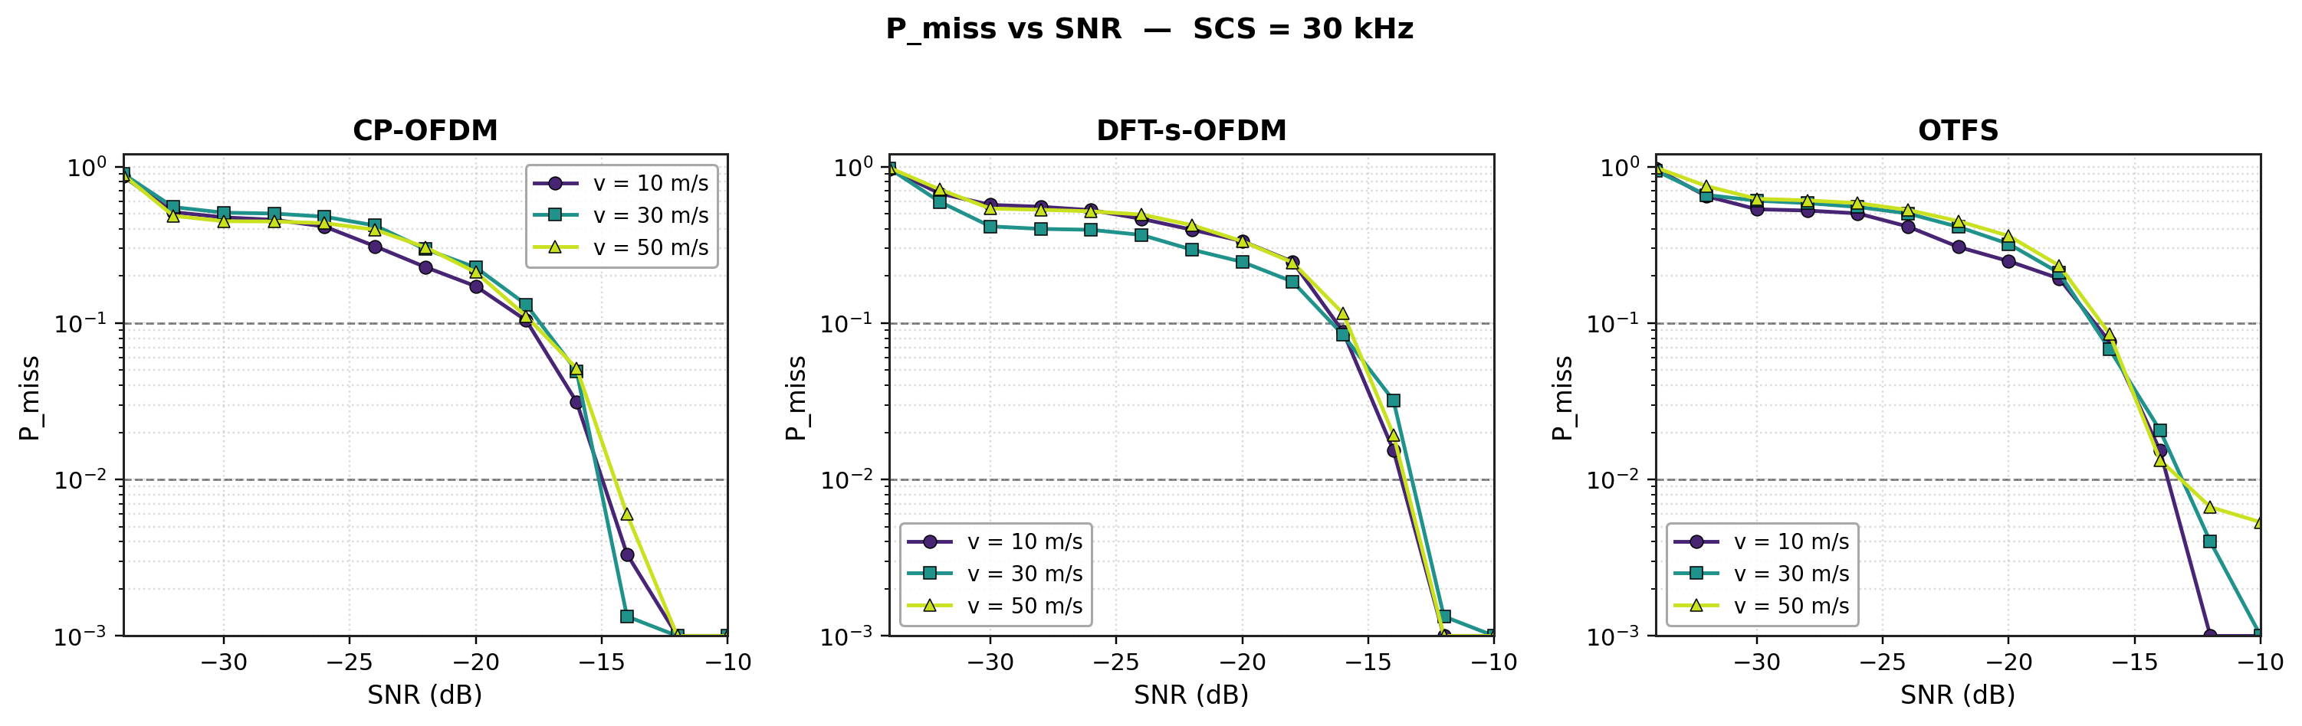
Figure 4. P_miss vs SNR, SCS = 30 kHz, v ∈ {10, 30, 50} m/s.
Simulation parameters: SCS = 30 kHz, N_RB = 51, numSlots = 20, CPI = 10 ms, DFT-s-OFDM mrb = 51 (full sensing-campaign allocation), P_FA = 5 %, K_chan · n_noise = 150 × 10 = 1500, dashed lines: P_miss = 10⁻¹ and 10⁻² operating points.
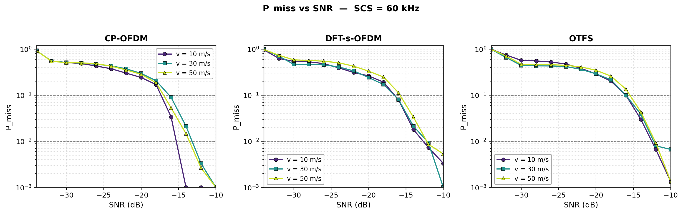
Figure 5. P_miss vs SNR, SCS = 60 kHz, v ∈ {10, 30, 50} m/s.
Simulation parameters: SCS = 60 kHz, N_RB = 51, numSlots = 40, CPI = 10 ms, DFT-s-OFDM mrb = 51 (full sensing-campaign allocation), P_FA = 5 %, K_chan · n_noise = 150 × 10 = 1500, dashed lines: P_miss = 10⁻¹ and 10⁻² operating points.
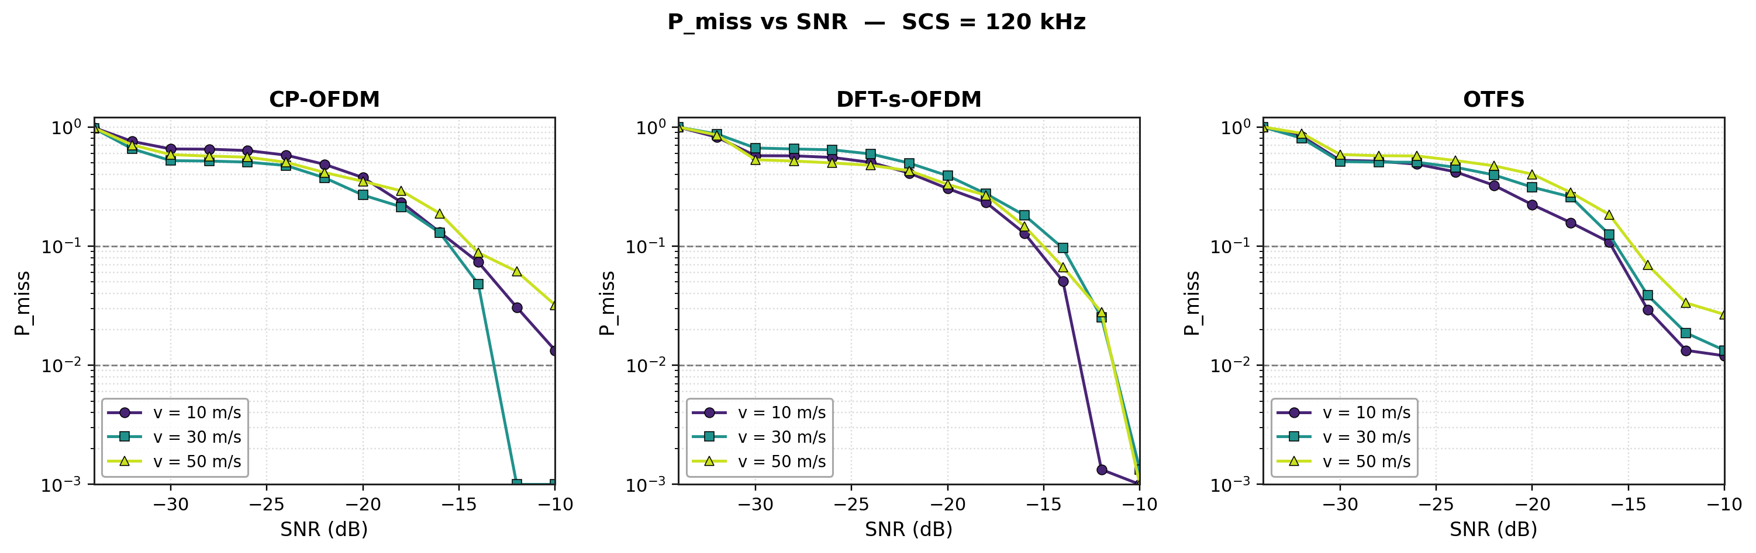
Figure 6. P_miss vs SNR, SCS = 120 kHz, v ∈ {10, 30, 50} m/s.
Simulation parameters: SCS = 120 kHz, N_RB = 51, numSlots = 80, CPI = 10 ms, DFT-s-OFDM mrb = 51 (full sensing-campaign allocation), P_FA = 5 %, K_chan · n_noise = 75 × 10 = 750, dashed lines: P_miss = 10⁻¹ and 10⁻² operating points.
Detection performance — SCS overlay (v = 30 m/s)
Figure 4 overlays the three SCS curves at the mid-velocity slice. The detection waterfall shifts right (worse SNR for the same P_miss) as SCS increases — see Observation 3 for the iso-CPI scaling discussion.
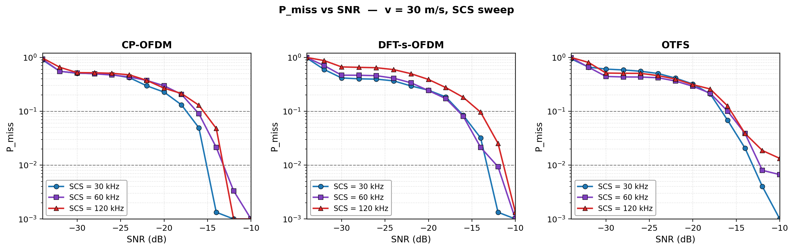
Figure 7. P_miss vs SNR, all SCS, v = 30 m/s.
Simulation parameters: v = 30 m/s, three-SCS overlay; numSlots scaled to keep CPI = 10 ms. Same trial budget as Fig. 4–6.

Table 3 lists the SNR (dB) at which each waveform first crosses P_miss = 5 % (with CFAR P_FA = 5 %), for every (SCS, v) combination. The yellow-shaded cell on each row is the per-row winner. Negative values mean the waveform meets the target at very low SNR; lower is better.

Table 3. SNR (dB) at which P_miss = 5 % is first met. Trials per cell: 1500 for SCS = 30 / 60 kHz, 750 for SCS = 120 kHz (resolution floor ≈ 1.3 × 10⁻³)
SCS | v (m/s) | CP-OFDM | DFT-s-OFDM | OTFS
(kHz) | — | SNR (dB) @ P_miss = 5 % | SNR (dB) @ P_miss = 5 % | SNR (dB) @ P_miss = 5 %
30 | 10 | -16.51 | -14.95 | -15.14
 | 30 | -16.02 | -14.69 | -15.24
 | 50 | -15.94 | -14.64 | -15.02
60 | 10 | -16.24 | -15.04 | -14.57
 | 30 | -14.83 | -14.97 | -14.37
 | 50 | -15.83 | -14.42 | -14.14
120 | 10 | -12.91 | -13.97 | -14.53
 | 30 | -14.05 | -12.70 | -14.26
 | 50 | -11.23 | -13.14 | -12.93

Observation 4: In the detection performance with varying velocity and SCS, all three waveforms perform equally well under the simulation assumptions in Table 2. There is no waveform that shows a disadvantage among the three candidates.
PAPR characterization
Figure 8 shows the CCDF of per-OFDM-symbol PAPR after 4× Tx oversampling for the three waveforms. DFT-s-OFDM consistently saves ≈ 2.5–2.7 dB over CP-OFDM at the canonical CCDF = 10⁻³ reporting point. OTFS PAPR is essentially identical to CP-OFDM since the ISFFT pre-coding does not reduce the peak-to-average envelope.
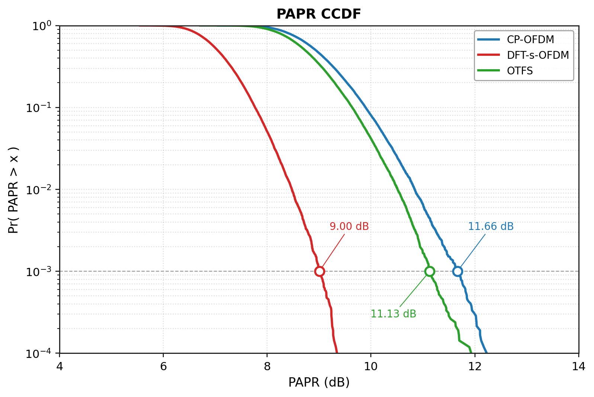
Figure 8. PAPR CCDF (3GPP-aligned 50-PRB allocation).
Simulation parameters: Per-OFDM-symbol PAPR with 4× Tx oversampling, 3000 trials, 16-QAM, full-band 50-PRB allocation (DFT-s-OFDM mrb = 50, the 3GPP TS 38.214 §5.1.2.2.1 valid factor — note this differs from the sensing campaign's mrb = 51 used in the P_miss / RMSE plots).
Observation 5: In the PAPR performance comparison of the waveforms, DFT-S-OFDM is better than CP-OFDM and OTFS and OTFS is slightly better than CP-OFDM under the simulation assumptions in Table 2
Ambiguity Function
Figure 9 shows the 2-D Range-Doppler periodogram for each waveform after passing the 38.901 section 7.9 ISAC channel and AWGN at SNR = −10 dB (well inside the P_miss < 10⁻³ region for all three waveforms). The periodogram is computed as the squared modulus of the slow-time / fast-time DFT of the equalised RE grid for CP-OFDM and DFT-s-OFDM, and via the SFFT lattice for OTFS. To make the three panels directly comparable in the presence of channel-induced floor and clutter, each panel is normalised to the peak inside a ±25 m × ±10 m/s window centred on the expected target — so the target neighbourhood appears at 0 dB across all three waveforms. The true target at (R = 180 m, v = +30 m/s) is marked by a cyan +.
Note on OTFS panel: residual ISFFT clutter is visible at (50 m, 0 m/s) and (250 m, −25 m/s); this is a known artefact of the SFFT path under the calibrated multipath profile and does NOT translate into a detection failure (the CFAR detector uses a local-window noise estimate, not a global argmax — OTFS PMD ≈ 0 at this SNR). .
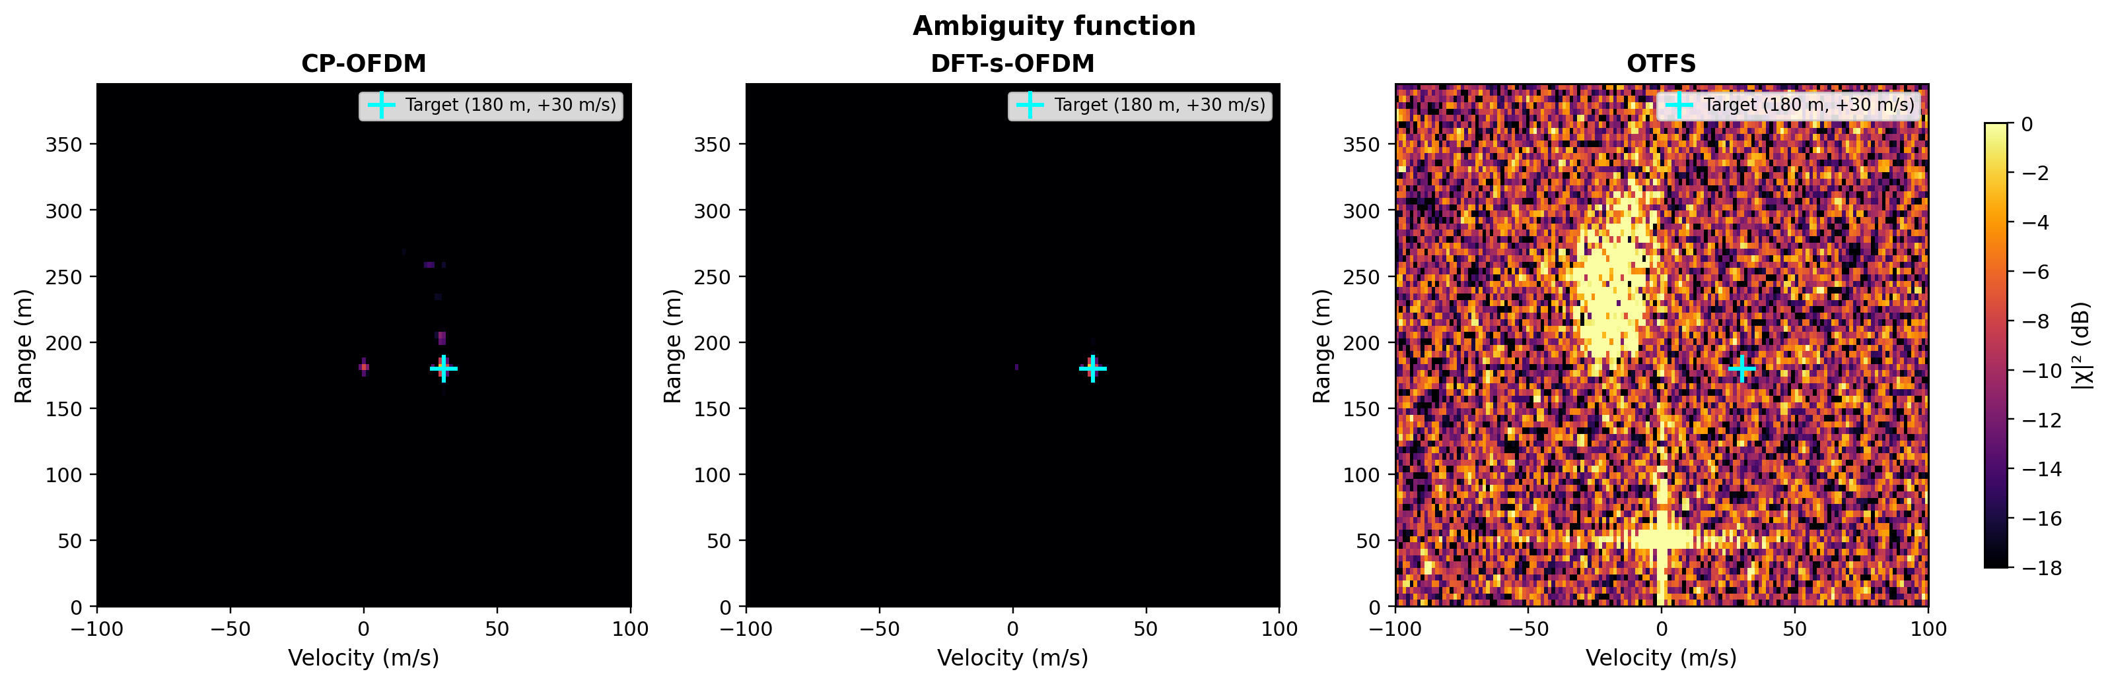
Figure 9. Ambiguity function, three waveforms, SNR = −10 dB, target = (180 m, 30 m/s).
Simulation parameters: SCS = 30 kHz, N_RB = 51, numSlots = 20, CPI = 10 ms, single channel realisation at SNR = −10 dB. Each panel is normalised to the peak in a ±25 m × ±10 m/s window around the expected target, so the target neighbourhood appears at 0 dB across all three waveforms. OTFS panel: residual ISFFT clutter at (250 m, −25 m/s) and (50 m, 0 m/s) is visible because the calibrated channel produces a strong DC-Doppler artefact through the SFFT path; the target at (180 m, +30 m/s) is nonetheless detected by the CFAR detector (local-window noise estimate, not global argmax — see P_miss curves which confirm OTFS PMD ≈ 0 at this SNR).
Observation 6: In the Ambiguity Function performance comparison all three waveforms localize the target at (R = 180 m, v = +30 m/s) in the ISAC channel; the peak-to-floor ratio is similar across waveforms once each panel is normalized to its own peak, indicating that there is no waveform-intrinsic ambiguity disadvantage for the three candidates

Other waveform characteristics comparison
Simulations for CP-OFDM, output backoff (OBO) results have been evaluated using at carrier frequency 6 GHz with bandwidths of 20 MHz and 100 MHz. The simulations consider both UE power classes PC2 and PC3, with OBO performance detailed for inner and outer allocations. These findings provide insight into the OBO behavior across different bandwidths and power classes, supporting the assessment of CP-OFDM’s suitability for 6G sensing applications.
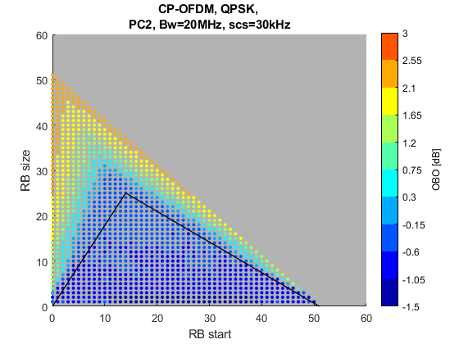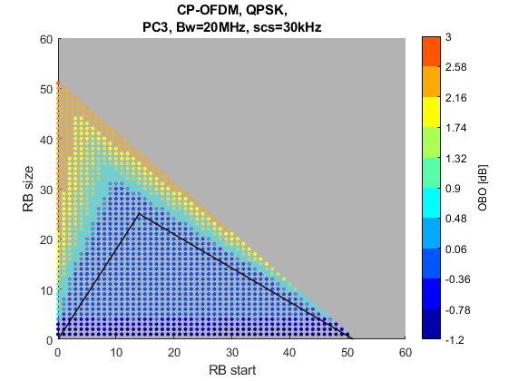
Figure 10: OBO results for CP-OFDM at 20MHz bandwidth for PC2 and PC3
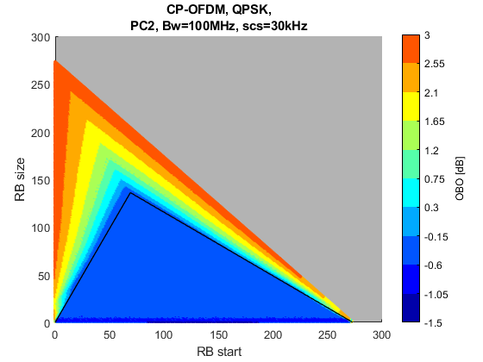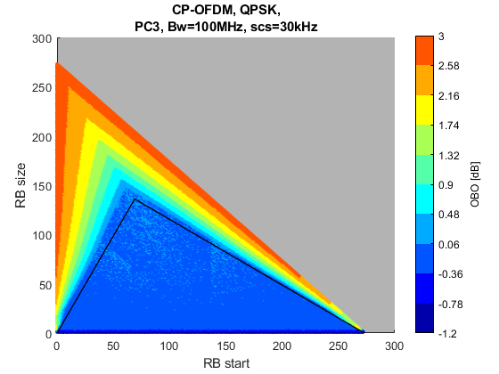
Figure 11: OBO results for CP-OFDM at 100MHz bandwidth for PC2 and PC3
In Figures 10 and 11, the interior of the triangle depicted in black represents the inner allocation, while the area outside of the triangle corresponds to the outer allocation.
Figure 12 and Figure 13 present the gating factor outcomes corresponding to the earlier OBO results, highlighting the influence of key metrics such as ACLR, SEM, IBE, and EVM , in accordance with the threshold criteria outlined in 3GPP TS 38.101 [7]. The performance evaluation should take into account the minimum requirements for signal quality and measurement accuracy. These parameters serve as the principal gating factors, determining the operational limits for each waveform under the specified simulation conditions. The figures illustrate how the gating factor varies across bandwidths and power classes, providing a direct comparison with the OBO findings and underscoring the importance of these metrics in waveform suitability assessment for 6G sensing applications.
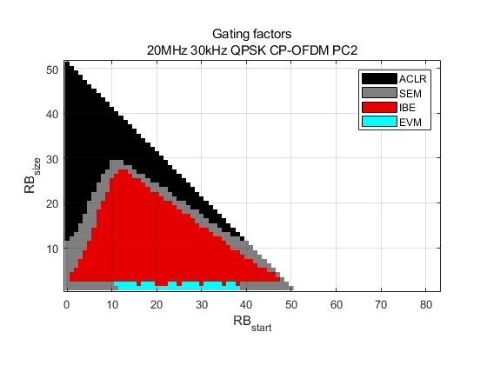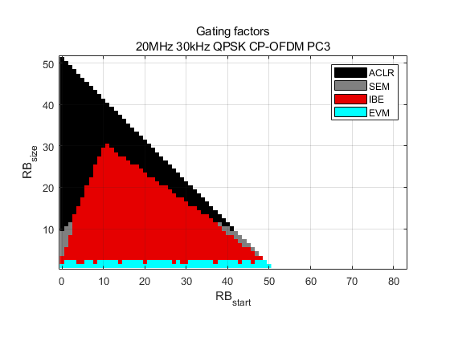
Figure 12: Gating factors for CP-OFDM at 20MHz bandwidth for PC2 and PC3

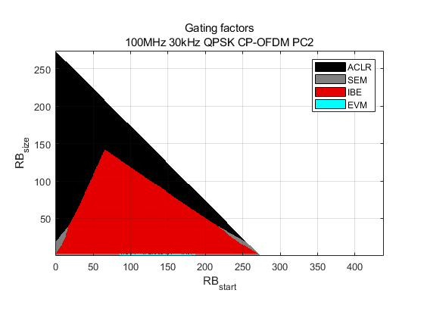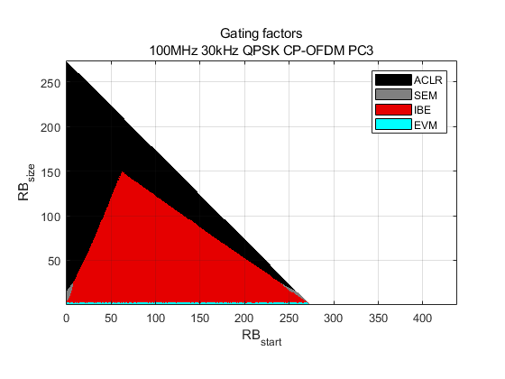
Figure 13: Gating factor for CP-OFDM at 100MHz bandwidth for PC2 and PC3
A key observation supporting the selection of CP-OFDM for sensing applications lies in its demonstrated performance across a range of bandwidths and power classes. The simulation results at 6 GHz, covering 20 MHz and 100 MHz bandwidths as well as power classes PC2 and PC3, reveal that CP-OFDM maintains stable output backoff (OBO) characteristics and meets the principal gating factors such as ACLR, SEM, IBE, and EVM, as stipulated by the 3GPP TS 38.101 requirements. Thus, CP-OFDM can provide reliable signal quality and measurement accuracy, making it a strong candidate for 6G sensing use cases. Furthermore, the consistency of its performance across inner and outer allocations further reinforces its suitability for integrated sensing and communication scenarios.
Observation 7: CP-OFDM demonstrates robust and consistent performance across varied bandwidths and power classes, reliably meeting key gating criteria for signal quality and measurement accuracy. This consistency across inner and outer allocations highlights its strong potential for sensing systems.
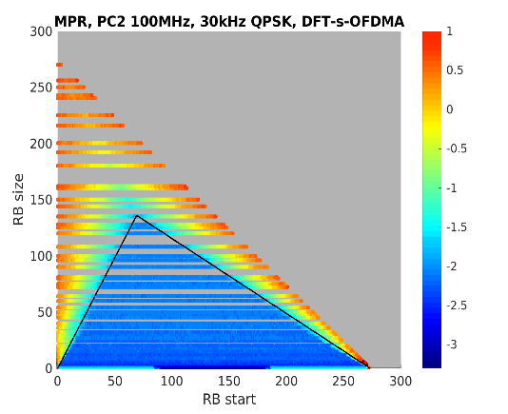
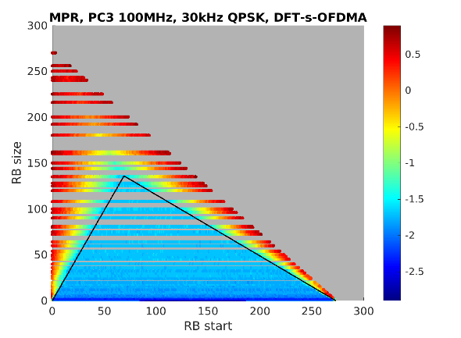
Figure 14 illustrates the output backoff (OBO) results for the DFT-s-OFDM waveform, evaluated across power classes PC2 and PC3. Additionally, Figures 15 presents the corresponding gating factors, providing a comprehensive assessment of DFT-s-OFDM's compliance with signal quality and measurement requirements.
OBO [dB]
OBO [dB]
Figure 14: OBO results for DFT-s-OFDM at 100MHz bandwidth for PC2 and PC3

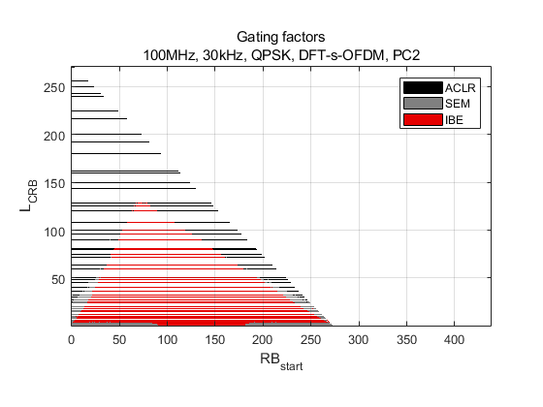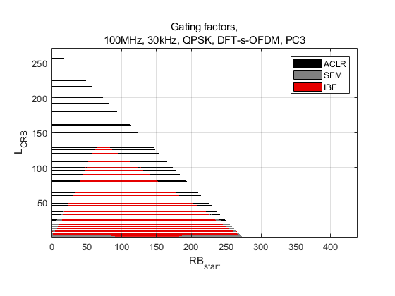
Figure 15: Gating factor for DFT-s-OFDM at 100MHz bandwidth for PC2 and PC3
Observation 8: For DFT-s-OFDM at 100MHz bandwidth, the principal gating factors impacting performance are ACLR, SEM, and EVM.
To conclude, the OBO analysis for DFT-s-OFDM at 100 MHz bandwidth shows that this waveform provides satisfactory output backoff for both PC2 and PC3 power classes. Its OBO profile demonstrates a strong balance between efficiency and linearity at large bandwidths, making DFT-s-OFDM well suited for 6G sensing scenarios that require both power economy and signal quality. In comparison, CP-OFDM remains notable for its consistently reliable signal quality and measurement precision across more varied bandwidths and power classes. While both DFT-s-OFDM and CP-OFDM meet critical gating requirements such as ACLR, SEM, and EVM, CP-OFDM’s stable operation for both inner and outer allocations further affirms its fitness sensing service. Therefore, DFT-s-OFDM emerges as a compelling option where energy efficiency is crucial, whereas CP-OFDM stands as the preferred choice for signal reliability.
Proposal 13: Agree on the evaluation assumptions for waveform comparisons. Take the assumptions in Table 2 as the starting point.
Proposal 14. Discuss and agree on the KPIs and waveform characteristics for the waveform comparisons.

Conclusion
In this contribution, we have the following observations and proposals for the discussion and adoption in RAN1-#125:
Observation 1: CP-OFDM outperforms the OTFS and DFT-s-OFDM in the detection performance under the simulation assumptions in Table 2.
Observation 2: In the RMSE performance of the range estimation, all three waveforms perform equally well under the simulation assumptions in Table 2
Observation 3: In the RMSE performance of the radial velocity estimation, all three waveforms perform equally well under the simulation assumptions in Table 2
Observation 4: In the detection performance with varying velocity and SCS, all three waveforms perform equally well under the simulation assumptions in Table 2. There is no waveform that shows a disadvantage among the three candidates.
Observation 5: In the PAPR performance comparison of the waveforms, DFT-S-OFDM is better than CP-OFDM and OTFS and OTFS is slightly better than CP-OFDM under the simulation assumptions in Table 2
Observation 6: In the Ambiguity Function performance comparison, all three waveforms localize the target at (R = 180 m, v = +30 m/s) in the ISAC channel; the peak-to-floor ratio is similar across waveforms once each panel is normalized to its own peak, indicating that there is no waveform-intrinsic ambiguity disadvantage for the three candidates
Observation 7: CP-OFDM demonstrates robust and consistent performance across varied bandwidths and power classes, reliably meeting key gating criteria for signal quality and measurement accuracy. This consistency across inner and outer allocations highlights its strong potential for sensing systems.
Observation 8: For DFT-s-OFDM at 100MHz bandwidth, the principal gating factors impacting performance are ACLR, SEM, and EVM.

Proposal 1: DFT-S-OFDM is studied as one of the UE-side sensing TX waveforms for 6GR sensing.
Proposal 2. DFT-S-OFDM is not considered as one of the aNB-side sensing TX waveforms for 6GR sensing.
Proposal 3. Possible enhancements to CP-OFDM will be studied in RAN1 for 6GR sensing for aNB and UE transmitting waveforms, including pulse-type signals. They are
  - PAPR reduction
  - Reduction of PSLR and ISLR
  - Ambiguity function reduction

Proposal 4: The enhancements to DFT-S-OFDM in the 6G UL communication are the starting point of the enhancements to DFT-S-OFDM for 6G sensing.
Proposal 5. Additional enhancements to DFT-S-OFDM may be studied in RAN1 for 6GR sensing for UE transmitting waveform, including pulse-type signals. They are
  - PAPR reduction
  - Reduction of PSLR and ISLR
  - Ambiguity function reduction
  - FDSS

Proposal 6. Study the LFM pulse -type signal in the CP-OFDM and DFT-S-OFDM framework for 6G Sensing
Proposal 7: Study the following options for the configuration of sensing occasions on top of the 6GR communication frame structure:
- Option 1: Lookup-table-based configuration.
- Option 2: Parametrized configuration.

Proposal 8: Study which 6GR symbol types (DL, UL, flexible, guard period, SBFD, sensing symbols or a mix) can be used for sensing.
Proposal 9: Study whether time-domain and frequency-domain configuration of sensing occasions are configured by separate parameters.
Proposal 10: Link-level channel modeling is necessary for waveform and sensing reference signal comparisons
Proposal 11: The CDL model is used as the 6G ISAC link-level channel model with one or more clusters for target channel clusters.
Option1: One or more clusters in the CDL channel model are updated
Option2: One or more clusters are added to the CDL channel model
The channel generation steps and parameter values of the target cluster(s) are FFS.
Proposal 12: The following waveform characteristics will be evaluated for waveform comparison in the 6G ISAC.
- PAPR
- Ambiguity Function (AF)
- PSLR
- ISLR
- OBO
- ACLR, OOBE

Proposal 13: Agree on the evaluation assumptions for waveform comparisons. Take the assumptions in Table 2 as the starting point.
Proposal 14. Discuss and agree on the KPIs and waveform characteristics for the waveform comparisons.

References
- RP-253876 Revised SID: Study on 6G Radio (Revision of RP-252912)
- RP-251861 New SID: Study on Integrated Sensing And Communication (ISAC) for NR
[3] RP-234069 New SID: Study on channel modeling for Integrated Sensing and Communication (ISAC) for NR
[4] TR 38.901 3GPP TSG RAN: Study on channel model for frequencies from 0.5 to 100 GHz
[5] TR 38.914 3GPP TSG RAN: Study on 6G Scenarios and Requirements
[6] Amitava Ghosh et.al. “A Unified Future: Integrated Sensing and Communication (ISAC) in 6G,” IEEE Journal of Selected Topics in Electromagnetics, Antennas, and Propagation, August 2025
[7] TS 38.101 3GPP Technical Specification: NR; User Equipment (UE) radio transmission and reception

